
附件2
创新点亮生活
习惯伴随一生

每日一设想（创意）记录册

学校名称：
学生姓名：
学生学号：
学生电话：
学生专业：
电子邮箱：
指导教师：

往年优秀作品范例1：
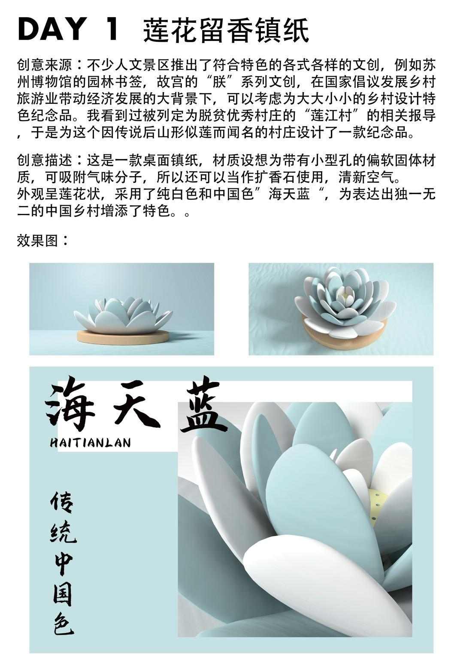

往年优秀作品范例2：

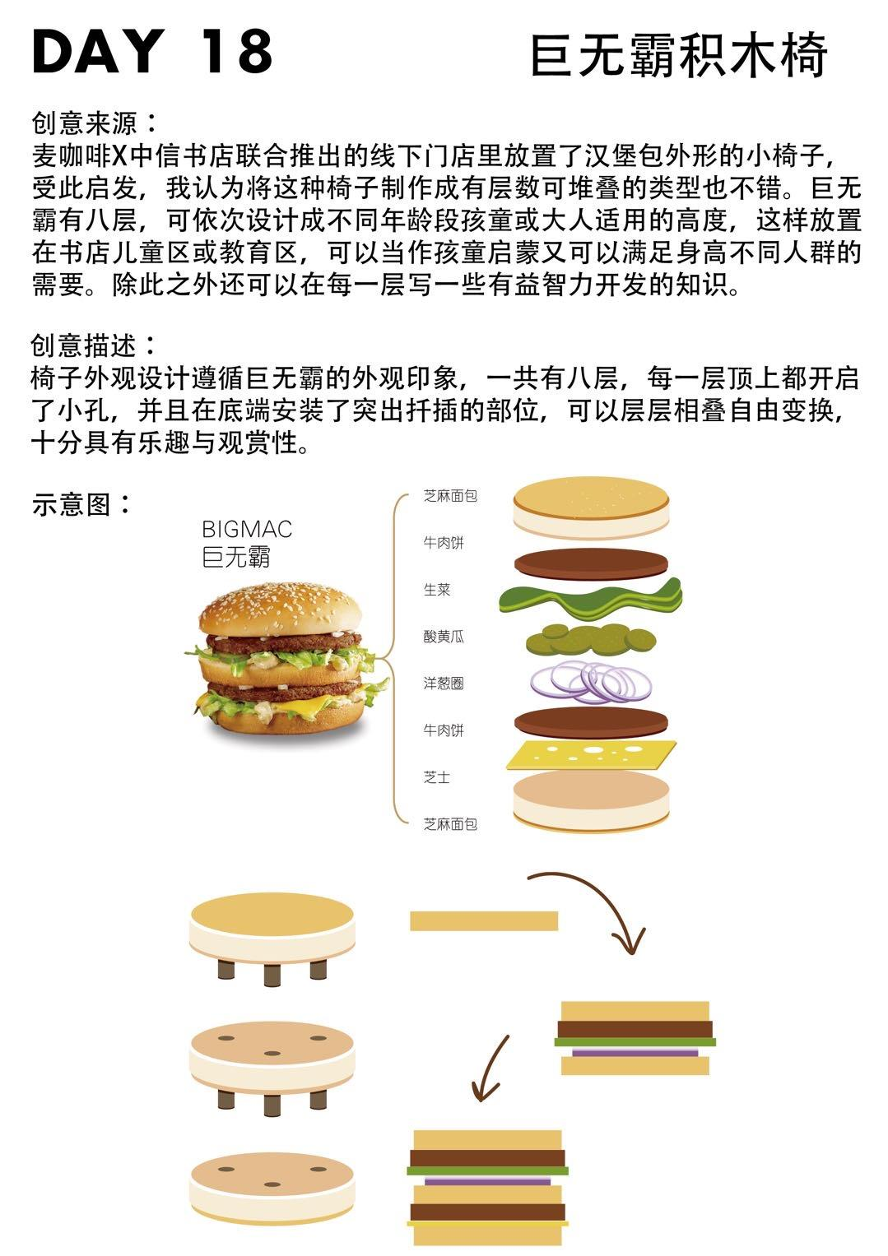

创作日期 年 月 日

作品名称：___________________________________

创意来源：______________________________________________________________
____________________________________________________________________________
____________________________________________________________________________
____________________________________________________________________________
创意描述：_________________________________________________________________
____________________________________________________________________________
____________________________________________________________________________
____________________________________________________________________________
作品示意图与说明，请画于以下空白处

创作日期 年 月 日

作品名称：___________________________________

创意来源：______________________________________________________________
____________________________________________________________________________
____________________________________________________________________________
____________________________________________________________________________
创意描述：_________________________________________________________________
____________________________________________________________________________
____________________________________________________________________________
____________________________________________________________________________
作品示意图与说明，请画于以下空白处

创作日期 年 月 日

作品名称：___________________________________

创意来源：______________________________________________________________
____________________________________________________________________________
____________________________________________________________________________
____________________________________________________________________________
创意描述：_________________________________________________________________
____________________________________________________________________________
____________________________________________________________________________
____________________________________________________________________________
作品示意图与说明，请画于以下空白处

创作日期 年 月 日

作品名称：___________________________________

创意来源：______________________________________________________________
____________________________________________________________________________
____________________________________________________________________________
____________________________________________________________________________
创意描述：_________________________________________________________________
____________________________________________________________________________
____________________________________________________________________________
____________________________________________________________________________
作品示意图与说明，请画于以下空白处

创作日期 年 月 日

作品名称：___________________________________

创意来源：______________________________________________________________
____________________________________________________________________________
____________________________________________________________________________
____________________________________________________________________________
创意描述：_________________________________________________________________
____________________________________________________________________________
____________________________________________________________________________
____________________________________________________________________________
作品示意图与说明，请画于以下空白处

创作日期 年 月 日

作品名称：___________________________________

创意来源：______________________________________________________________
____________________________________________________________________________
____________________________________________________________________________
____________________________________________________________________________
创意描述：_________________________________________________________________
____________________________________________________________________________
____________________________________________________________________________
____________________________________________________________________________
作品示意图与说明，请画于以下空白处

创作日期 年 月 日

作品名称：___________________________________

创意来源：______________________________________________________________
____________________________________________________________________________
____________________________________________________________________________
____________________________________________________________________________
创意描述：_________________________________________________________________
____________________________________________________________________________
____________________________________________________________________________
____________________________________________________________________________
作品示意图与说明，请画于以下空白处

创作日期 年 月 日

作品名称：___________________________________

创意来源：______________________________________________________________
____________________________________________________________________________
____________________________________________________________________________
____________________________________________________________________________
创意描述：_________________________________________________________________
____________________________________________________________________________
____________________________________________________________________________
____________________________________________________________________________
作品示意图与说明，请画于以下空白处

创作日期 年 月 日

作品名称：___________________________________

创意来源：______________________________________________________________
____________________________________________________________________________
____________________________________________________________________________
____________________________________________________________________________
创意描述：_________________________________________________________________
____________________________________________________________________________
____________________________________________________________________________
____________________________________________________________________________
作品示意图与说明，请画于以下空白处

创作日期 年 月 日

作品名称：___________________________________

创意来源：______________________________________________________________
____________________________________________________________________________
____________________________________________________________________________
____________________________________________________________________________
创意描述：_________________________________________________________________
____________________________________________________________________________
____________________________________________________________________________
____________________________________________________________________________
作品示意图与说明，请画于以下空白处

创作日期 年 月 日

作品名称：___________________________________

创意来源：______________________________________________________________
____________________________________________________________________________
____________________________________________________________________________
____________________________________________________________________________
创意描述：_________________________________________________________________
____________________________________________________________________________
____________________________________________________________________________
____________________________________________________________________________
作品示意图与说明，请画于以下空白处

创作日期 年 月 日

作品名称：___________________________________

创意来源：______________________________________________________________
____________________________________________________________________________
____________________________________________________________________________
____________________________________________________________________________
创意描述：_________________________________________________________________
____________________________________________________________________________
____________________________________________________________________________
____________________________________________________________________________
作品示意图与说明，请画于以下空白处

创作日期 年 月 日

作品名称：___________________________________

创意来源：______________________________________________________________
____________________________________________________________________________
____________________________________________________________________________
____________________________________________________________________________
创意描述：_________________________________________________________________
____________________________________________________________________________
____________________________________________________________________________
____________________________________________________________________________
作品示意图与说明，请画于以下空白处

创作日期 年 月 日

作品名称：___________________________________

创意来源：______________________________________________________________
____________________________________________________________________________
____________________________________________________________________________
____________________________________________________________________________
创意描述：_________________________________________________________________
____________________________________________________________________________
____________________________________________________________________________
____________________________________________________________________________
作品示意图与说明，请画于以下空白处

创作日期 年 月 日

作品名称：___________________________________

创意来源：______________________________________________________________
____________________________________________________________________________
____________________________________________________________________________
____________________________________________________________________________
创意描述：_________________________________________________________________
____________________________________________________________________________
____________________________________________________________________________
____________________________________________________________________________
作品示意图与说明，请画于以下空白处

创作日期 年 月 日

作品名称：___________________________________

创意来源：______________________________________________________________
____________________________________________________________________________
____________________________________________________________________________
____________________________________________________________________________
创意描述：_________________________________________________________________
____________________________________________________________________________
____________________________________________________________________________
____________________________________________________________________________
作品示意图与说明，请画于以下空白处

创作日期 年 月 日

作品名称：___________________________________

创意来源：______________________________________________________________
____________________________________________________________________________
____________________________________________________________________________
____________________________________________________________________________
创意描述：_________________________________________________________________
____________________________________________________________________________
____________________________________________________________________________
____________________________________________________________________________
作品示意图与说明，请画于以下空白处

创作日期 年 月 日

作品名称：___________________________________

创意来源：______________________________________________________________
____________________________________________________________________________
____________________________________________________________________________
____________________________________________________________________________
创意描述：_________________________________________________________________
____________________________________________________________________________
____________________________________________________________________________
____________________________________________________________________________
作品示意图与说明，请画于以下空白处

创作日期 年 月 日

作品名称：___________________________________

创意来源：______________________________________________________________
____________________________________________________________________________
____________________________________________________________________________
____________________________________________________________________________
创意描述：_________________________________________________________________
____________________________________________________________________________
____________________________________________________________________________
____________________________________________________________________________
作品示意图与说明，请画于以下空白处

创作日期 年 月 日

作品名称：___________________________________

创意来源：______________________________________________________________
____________________________________________________________________________
____________________________________________________________________________
____________________________________________________________________________
创意描述：_________________________________________________________________
____________________________________________________________________________
____________________________________________________________________________
____________________________________________________________________________
作品示意图与说明，请画于以下空白处

创作日期 年 月 日

作品名称：___________________________________

创意来源：______________________________________________________________
____________________________________________________________________________
____________________________________________________________________________
____________________________________________________________________________
创意描述：_________________________________________________________________
____________________________________________________________________________
____________________________________________________________________________
____________________________________________________________________________
作品示意图与说明，请画于以下空白处

创作日期 年 月 日

作品名称：___________________________________

创意来源：______________________________________________________________
____________________________________________________________________________
____________________________________________________________________________
____________________________________________________________________________
创意描述：_________________________________________________________________
____________________________________________________________________________
____________________________________________________________________________
____________________________________________________________________________
作品示意图与说明，请画于以下空白处

创作日期 年 月 日

作品名称：___________________________________

创意来源：______________________________________________________________
____________________________________________________________________________
____________________________________________________________________________
____________________________________________________________________________
创意描述：_________________________________________________________________
____________________________________________________________________________
____________________________________________________________________________
____________________________________________________________________________
作品示意图与说明，请画于以下空白处

创作日期 年 月 日

作品名称：___________________________________

创意来源：______________________________________________________________
____________________________________________________________________________
____________________________________________________________________________
____________________________________________________________________________
创意描述：_________________________________________________________________
____________________________________________________________________________
____________________________________________________________________________
____________________________________________________________________________
作品示意图与说明，请画于以下空白处

创作日期 年 月 日

作品名称：___________________________________

创意来源：______________________________________________________________
____________________________________________________________________________
____________________________________________________________________________
____________________________________________________________________________
创意描述：_________________________________________________________________
____________________________________________________________________________
____________________________________________________________________________
____________________________________________________________________________
作品示意图与说明，请画于以下空白处

创作日期 年 月 日

作品名称：___________________________________

创意来源：______________________________________________________________
____________________________________________________________________________
____________________________________________________________________________
____________________________________________________________________________
创意描述：_________________________________________________________________
____________________________________________________________________________
____________________________________________________________________________
____________________________________________________________________________
作品示意图与说明，请画于以下空白处

创作日期 年 月 日

作品名称：___________________________________

创意来源：______________________________________________________________
____________________________________________________________________________
____________________________________________________________________________
____________________________________________________________________________
创意描述：_________________________________________________________________
____________________________________________________________________________
____________________________________________________________________________
____________________________________________________________________________
作品示意图与说明，请画于以下空白处

创作日期 年 月 日

作品名称：___________________________________

创意来源：______________________________________________________________
____________________________________________________________________________
____________________________________________________________________________
____________________________________________________________________________
创意描述：_________________________________________________________________
____________________________________________________________________________
____________________________________________________________________________
____________________________________________________________________________
作品示意图与说明，请画于以下空白处

创作日期 年 月 日

作品名称：___________________________________

创意来源：______________________________________________________________
____________________________________________________________________________
____________________________________________________________________________
____________________________________________________________________________
创意描述：_________________________________________________________________
____________________________________________________________________________
____________________________________________________________________________
____________________________________________________________________________
作品示意图与说明，请画于以下空白处

创作日期 年 月 日

作品名称：___________________________________

创意来源：______________________________________________________________
____________________________________________________________________________
____________________________________________________________________________
____________________________________________________________________________
创意描述：_________________________________________________________________
____________________________________________________________________________
____________________________________________________________________________
____________________________________________________________________________
作品示意图与说明，请画于以下空白处

心得体会：
____________________________________________________________________________
____________________________________________________________________________
____________________________________________________________________________
____________________________________________________________________________
____________________________________________________________________________
____________________________________________________________________________

指导教师点评：
____________________________________________________________________________
____________________________________________________________________________
____________________________________________________________________________
____________________________________________________________________________
____________________________________________________________________________

总结日期 年 月 日

